**The 7 habits of highly effective people**

Stephen R. Covey

**Sharpen the saw**

**7**

**2**

**Begin with the end in mind**

**Put first things first**

**3**

**4**

**Think Win/Win**

**6**

**5**

**Synergize**

**Seek first to understand …**

**then to be**

**understood**

**Interdependence**

**Dependence**

**Independence**

**PUBLIC VICTORY**

**PRIVATE VICTORY**

**Be proactive**

**1**

“The seven habits of highly effective people” by Stephen R. Covey, ISBN 978-1451639612

**Meet your colleague**

**Exercise in pairs – 10 minutes in total**

1. Meet another participant and interview each other very briefly using the following questions:
2. Who are you (name, faculty, PhD year)?
3. How would you describe the current interaction within your research team?
4. What do you want to learn in this course?
5. Make notes of the answers of your colleague.
6. Introduce your colleague to the group in 30 seconds.

**Braindump concerns**

**Individual exercise – 10 minutes in total**

1. The big circle is your Circle of Concern, containing all your concerns
2. The inner circle is your Circle of Influence, containing all your concerns you can do something about
3. Put the concerns that you have influence on in your CoI
4. Put the concerns that you have no influence on in your CoC

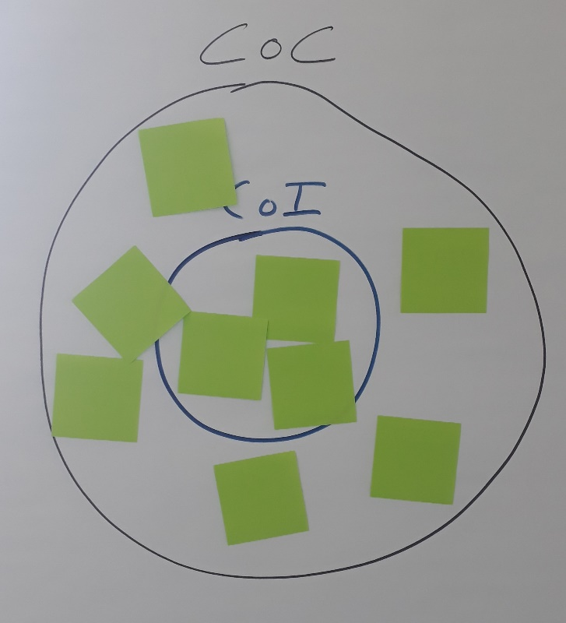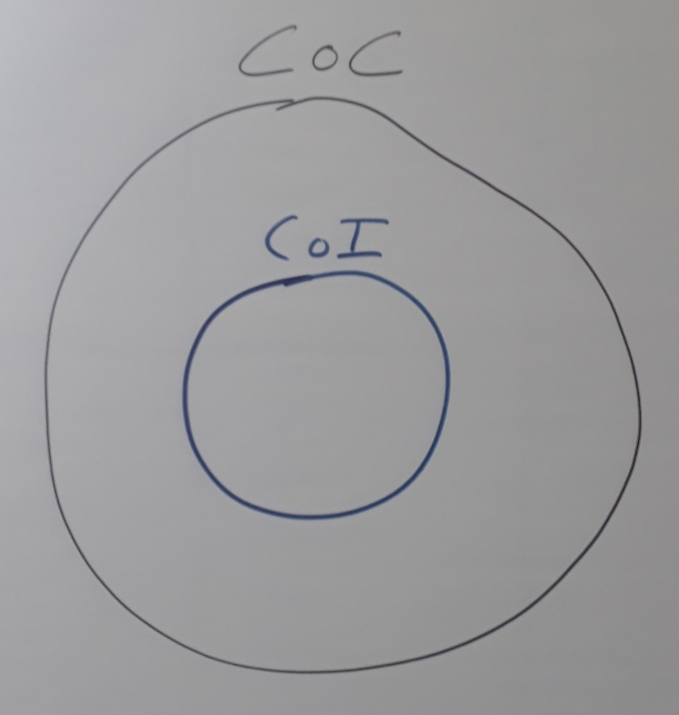

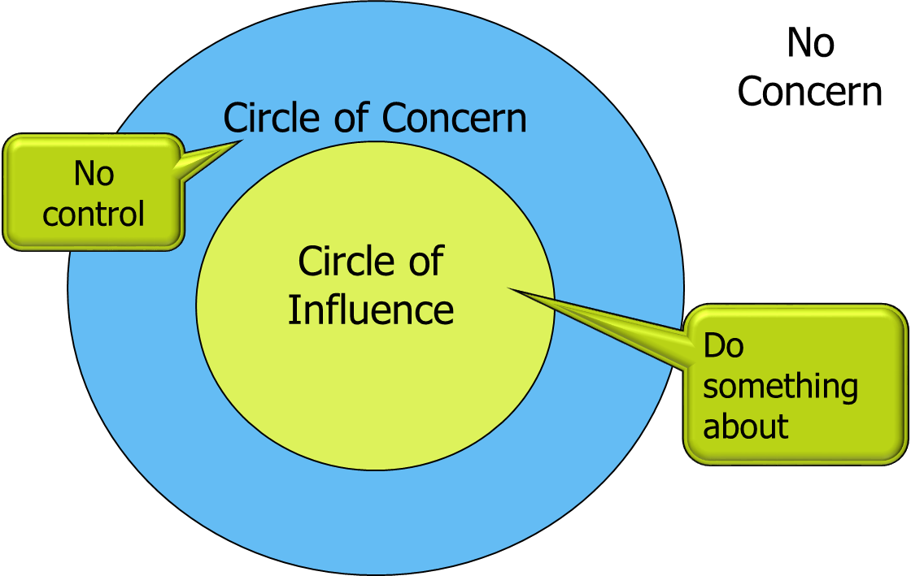

**Habit 1** – Habit 2 – Habit 3 – Habit 4 – Habit 5 – Habit 6 – Habit 7

**Be Proactive**

**Proactive model**

Understanding that Visualize alternative Consult your Power to

you have a choice responses inner compass choose freely

|  |  |
| --- | --- |
| **Reactive language** | **Proactive language** |
| There’s nothing I can do | Let’s look at my alternatives |
| That’s just the way I am | I can choose a different approach |
| He makes me so mad | I decide how to act on my feelings |
| They won’t allow that | I can create ... |
| I have to do it that way | I will choose an appropriate response |
| I can’t | I choose |
| I must | I prefer |
| If only | I will do it |
|  |  |
|  |  |

**Be Proactive**

**Exercise in pairs – 15 minutes in total**

1. Pick an important concern from your Circle of Concern. Describe it to your colleague
2. Together examine the language you use in describing your concern: can you find any proactive / reactive language?
3. If the language is reactive, how can you make it proactive?
4. Does changing the language have any effect on the position of your concern (CoC or CoI)?

If both ready:

1. What examples of proactive or reactive language do you often hear within your own research team?

**Circle of Concern / Circle of Influence**

**Expanding the Circle of Influence**

**Being or Having?**

* Anytime we think the problem is “out there”, that thought is the problem
* We empower what’s out there to control us. What’s out there ***has*** to change before we can change
* The proactive approach is to change from the inside-out: to ***be*** different
* Reactive people focus their efforts in the Circle of Concern
* Proactive people focus their efforts in the Circle of Influence
* They work on ***being*** instead of ***having***

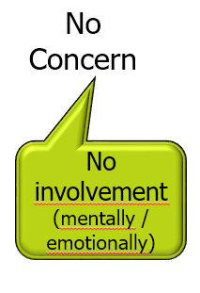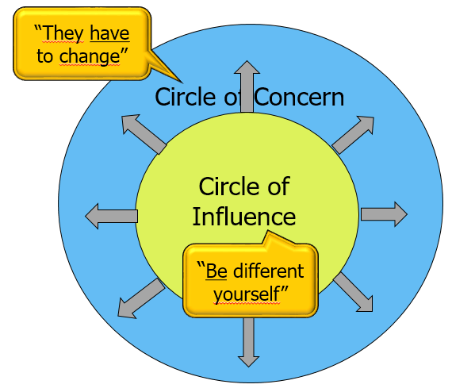

No control

Do something about

No Concern

No involvement (mentally / emotionally)

Habit 1 – **Habit 2** – Habit 3 – Habit 4 – Habit 5 – Habit 6 – Habit 7

**Begin with the end in mind**

**Roles, expectations and goals**

Your **roles** as a PhD candidate could be diverse. You are a researcher, maybe an engineer, a student (when taking courses) and maybe a supervisor yourself (supervising students), maybe a teacher or teaching assistant. Also you could be active in the TU community or have even other roles within your PhD.

In each role, **expectations** come from yourself: when are you successful in this particular role?

In addition, expectations also come from other people, like your supervisor, promoter, colleagues, others: what do they expect from you in this particular role? When do they consider you to be successful?

**Goals** are the things you *choose* to spend your time and energy on, because they are important to you. Goals are defined as a measurable outcome of a number of actions. To make them practical for this course, also define goals on how you would like to change the situation in your research team.

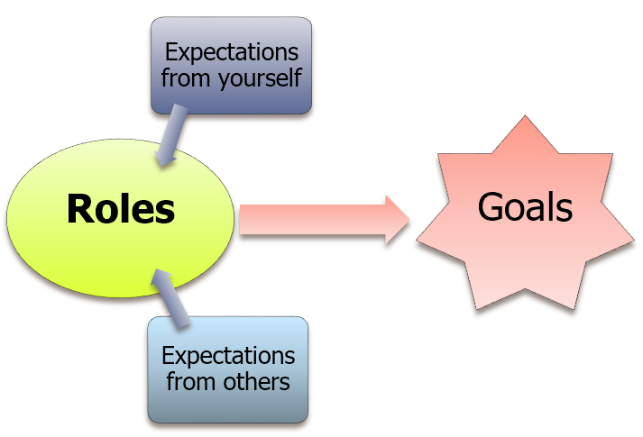

**Begin with the end in mind**

**Exercise in pairs – 20 minutes in total**

Beginning with the end in mind is done by defining your roles and setting your goals.

1. Look at your concerns within your CoI/CoC
2. Discuss the next questions, switch roles after 10 min
3. What (three) roles do I have as a PhD-candidate?

For each role:

1. What specific expectations do I have of myself?
2. What specific expectations do others have of me?
3. What difference in expectations could there be?
4. What long term goals do I want as a direction for this role?

Habit 1 – Habit 2 – **Habit 3** – Habit 4 – Habit 5 – Habit 6 – Habit 7

**Put first things first**

**Individual exercise – 10 minutes in total**

Putting first things first has to do with making choices, your own choices.

In this exercise we focus on how you can improve your independency in your research team.

Take another look at your concerns (flip) and at your goals (exercise previous page).

1. What concerns do you have influence on?
2. What goals are most important to you?
3. Reflecting on your answers to the previous two questions, which concern is most relevant / most important to tackle?

**Emotional Bank Account**

**Exercise in pairs – 20 minutes in total**

Exchange:

1. Share your example of a deposit you made in your working environment.
2. Share your example of a deposit you received from someone in your working environment.
3. Share what happens to you when someone makes a withdrawal?
4. See next page: For each of the six categories, together think of and discuss a deposit you could make in your working environment.
5. How does this relate to (one of) your concerns?

|  |  |  |
| --- | --- | --- |
| 1 | Understanding the individual | Specific deposit I could make: |
| 2 | Attending to the little things | Specific deposit I could make: |
| 3 | Keeping commitments | Specific deposit I could make: |
| 4 | Clarifying expectations | Specific deposit I could make: |
| 5 | Showing personal integrity | Specific deposit I could make: |
| 6 | Apologizing sincerely when you make a withdrawal | Specific deposit I could make: |

**Effective Communication**

**Communication levels**

**Components of non-violent communication**

**Basic rules of communication**

1. **Describe observable behaviour**

**FACTS**

*‘* ***I*** *see ...’ ‘* ***I*** *hear …’*

1. **Describe how it EFFECTS you**

*‘* ***I*** *feel …’ ‘* ***I*** *experience …’*

1. **Ask for a REACTION**

*‘ How do* ***you*** *feel about this* ***?*** *’* *‘ What is* ***your*** *reaction* ***?*** *’*

1. **Describe the alternative**

**your REQUEST**

*‘ Would* ***you*** *be willing …* ***?*** *’ ‘ Could* ***we / you*** *…* ***?*** *’*

**Do’s in communication**

* Announce that you want to address a topic
* Choose the right timing, don’t wait too long
* Be very specific on the content
* Use the ‘I’- form
* Be friendly on the person

**Don’ts in communication**

* Elaborate about the past
* Make interpretations
* Make convictions
* Talk in generalities and abstractions
* Present your opinion as a fact
* Present your request as a demand

**‘Addressing a topic’**

**Exercise in pairs - 30 minutes in total**

1. Choose a topic that you find difficult to address (see CoF and reflection exercise)
2. How would you formulate this message using the four basic rules of communication?
3. Write your message down:
4. Practice your message with your colleague ‘being’ the receiving party

Next step:

Role playing = practicing new behaviour in a safe environment.

PhD is his-/herself, colleague behaves as asked.

1. Sharing of cases
2. One case will be ‘played’ in the group
3. The volunteer will be her-/himself and will choose someone to represent the other party
4. The two will play the real situation
5. Others will observe to give feedback afterwards

**Observation form ‘Addressing a topic’**

Observation = observing the *facts*

What do you hear the person *saying*? = verbal and tonality

What do you see the person *doing*? = non-verbal: gestures, body language and position

1. Note moments in the interaction that attract your attention: what do you hear (verbal, as literally as possible) and what do you see (non-verbal)
2. Write down the effect on the other person, what does he/she say or do?
3. Do you have a suggestion for an alternative?

|  |  |  |
| --- | --- | --- |
| **What do you hear?**  (Verbal and tonality) | **What do you see?**  (Non-verbal) | **Effect on the other person** |
|  |  |  |
| Suggestions for alternatives: | | |

**Reflection day one**

**Individual exercise – 10 minutes in total**

In this exercise we focus on what you can do in order to become more in charge of your own situation.

1. What have you learned today about the interaction within your research team?
2. What would you like to change concerning the interaction within your research team?
3. Following on your answer to the previous question, what specific topic do you need to address (with your supervisor, promoter, colleague or other relationship)?
4. Prepare your case for the coming week. Note the context, the situation, your conversation partner and your goal of the conversation:

Share your reflections with the group.

**Emotional Intelligence**

**Brains and emotions**

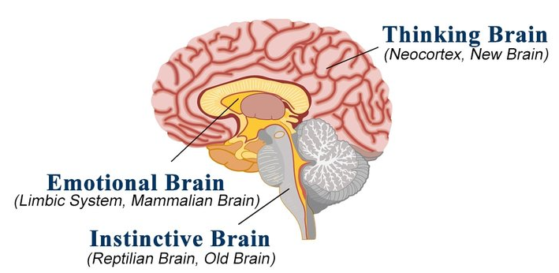

**Basic emotions and their functionality**

**By Marc Brackett – Permission to feel**

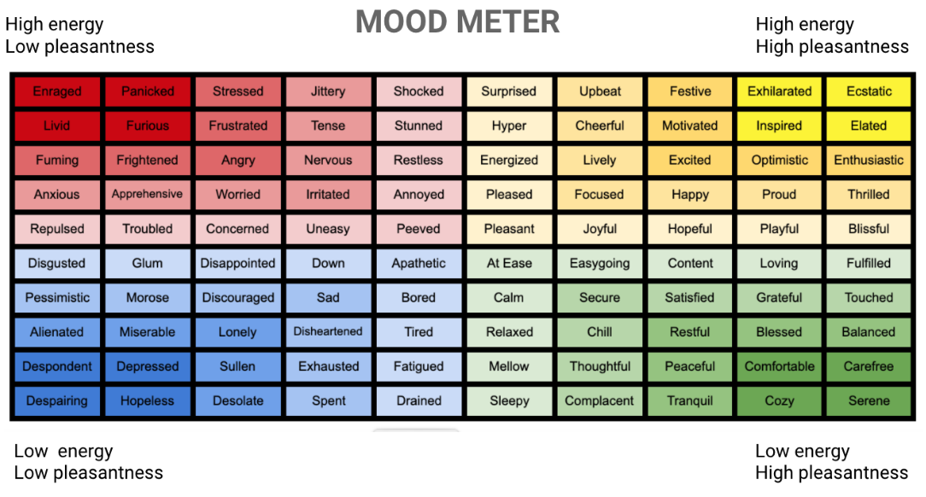

Habit 1 – Habit 2 – Habit 3 – Habit 4 – **Habit 5** – Habit 6 – Habit 7

**Seek first to understand... then to be understood**

**Autobiographical listening**

Autobiographical listening is projecting our own life story, our autobiography, and our own paradigms into the other person’s story, and respond accordingly. We assume thoughts, feelings, motives and interpretation. There are four autobiographical responses:

1. We **evaluate**

* agree or disagree

1. We **probe**

* ask questions from our own frame of reference

1. We **advise**

* give counsel based on our own experience

1. We **interpret**

* try to explain based on our own motives

**Empathic listening**

Empathic listening is listening with the intent to understand, to get inside the other person’s frame of reference, to really understand what’s going on inside him or her.

The skills of empathic listening consist of four developmental stages:

1. **Mimicking the content**

* active listening (not only ‘humming’, but interrupt to repeat: “So you are saying…”)
* repeating the words literally

1. **Rephrasing the content**

* use our own words for the same content
* summarizing the content
* using left brain

1. **Reflecting the feeling**

* using right brain also
* translate what you see and hear in tonality, facial expression and body language into a feeling

1. **Rephrasing the content and reflecting the feeling**

* combining 2 and 3
* summarize content with left brain (“So you are saying…”) and
* translate what you see in tonality, facial expression and body language with your right brain into a feeling (“You seem to be…”)

Stage four is empathic listening. You not only listen with your ears, but also –and more importantly – with your eyes and with your heart. You are dealing with the reality inside the other person’s head and heart. Empathic listening is a huge deposit in the Emotional Bank Account. And it is right in the middle of your Circle of Influence.

**Empathic listening**

**Exercise in groups of three – 30 minutes in total**

Three roles: Speaker, Listener, Observer. You change roles twice.

Part I

1. Speaker 1 explains one of his concerns to Listener 1
2. Listener 1 listens in his normal way
3. Observer 1 observes and notes examples of empathic and autobiographic listening
4. Observer 1 gives feedback to Listener 1

Change roles

Part II

1. Speaker 2 explains one of his concerns to Listener 2
2. Listener 2 practices: mimicking, summarizing and rephrasing the content (stage 1 & 2)
3. Observer 2 observes and notes examples of empathic and autobiographic listening
4. Speaker 2 continues till he feels completely understood
5. Observer 2 gives feedback to Listener 2

Change roles

Part III

1. Speaker 3 explains one of his concerns to Listener 3
2. Listener 3 practices: reflecting the feeling and rephrasing the content (stage 3 & 4)
3. Observer 3 observes and notes examples of empathic and autobio. listening
4. Speaker 3 continues till he feels completely understood
5. Observer 3 gives feedback to Listener 3

***Speaker 2 and 3 can make use of a talking stick:***

***you hold the stick until you feel completely understood***

**Observation form ‘Empathic listening’**

|  |  |
| --- | --- |
| **Empathic listening** | **Autobiographical listening** |
|  |  |

Habit 1 – Habit 2 – Habit 3 – **Habit 4** – Habit 5 – Habit 6 – Habit 7

**Think Win/Win – Courage and Consideration**

**Exercise in groups of three – 40 minutes in total**

Role playing = practicing new behaviour in a safe environment.

PhD is his-/herself, colleague behaves as asked.

1. Sharing of cases
2. You will all play your case in the group of three
3. You will choose one of the others to represent the other party
4. The third one will observe to give feedback afterwards
5. You will play the real situation, when stuck you can ‘pause’ and ask for tips, you can try several times
6. The oberver needs to watch the time

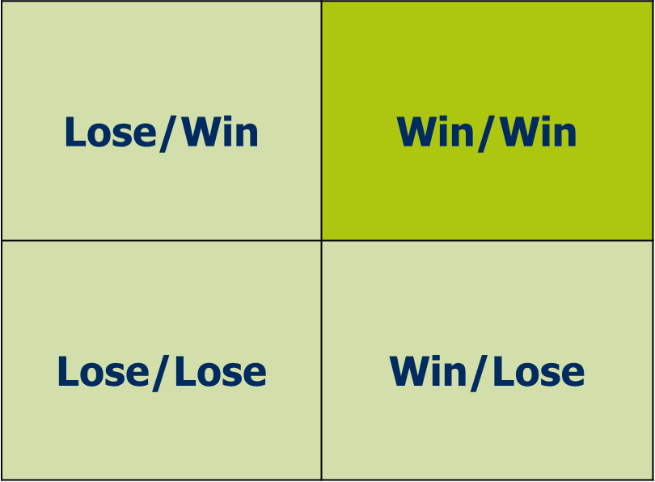

**Courage**

**Consideration**

Low

Low

High

High

High

**Observation form Think ‘Win/Win’**

1. Note moments in the interaction that attract your attention: what do you hear (verbal, as literally as possible) and what do you see (non-verbal)
2. Write down the effect on the other person, what does he/she say or do?
3. Do you have a suggestion for an alternative?

|  |  |  |
| --- | --- | --- |
| **What do you hear?**  (Verbal and tonality) | **What do you see?**  (Non-verbal) | **Effect on the other person** |
|  |  |  |
| What concepts do you recognize? (e.g. EBA, empathic/autobiographic listening, proactivity/reactivity, courage, consideration, communication rules, …) | | |
| Suggestions for alternatives: | | |

**Reflection on your interaction**

**Individual exercise - 10 minutes in total**

In this exercise we focus on how you can further improve your interaction within your research team.

1. What have you learned from the habits ‘think win/win’ and ‘empathic listening’?
2. Reflecting on your answer to the previous question, how could this help you to interact more effectively within your research team? Be as specific as possible.
3. Check your CoI/CoC, do you see any changes?
4. What concerns are left that you haven’t found an approach for yet?

Habit 1 – Habit 2 – Habit 3 – Habit 4 – Habit 5 – **Habit 6** – Habit 7

**Synergize**

**Synergy is**

* 1+1=3
* The whole is greater than the sum of its parts
* Creativity and energy
* Together on a journey, destiny unknown

**Four paradigms of synergy**

* I see myself

I have the power to stand outside myself and think about my own thoughts and feelings. I can examine my own motives.

* I see you

I have profound respect for you. I value your ideas, your experience, your perspective, and your feelings.

* I seek you out

I am fascinated – not threatened – by the gap between us. “you see things differently, I need to listen to you, I seek to understand”. It’s about mutual discovery of solutions, not about providing solutions.

* I synergize with you

Japanese ‘aiki’ = blending of strengths to create a harmonious result. This makes conflict irrelevant.

**The process of synergy**

Ask Are you willing to go for a solution that is better than any of us have come

up with yet?

Define Criteria of success.

Create Prototypes, avoid consensus, brainstorm new frameworks, reverse

conventional wisdom, suspend judgment, make models (show what you

think instead of telling it), work fast. The best place to find synergy is ‘at

the edges’, where people with divergent strengths and viewpoints cluster.

Arrive Excitement. Hesitation and conflict are gone.

**Synergize**

**Exercise in two groups – 40 minutes in total**

1. *(max 30 minutes)* Discuss the following questions:
2. How could you define synergy in a research environment?
3. What do you consider to be characteristics of a synergistic research result?
4. What conditions are needed within a research team to foster such a synergy?
5. What can *you* do as a PhD-candidate to foster synergy in *your* research team?
6. *(max 10 minutes)* Prepare a presentation to show us your answers in a creative way, making use of
7. the qualities of each of you
8. the differences between each of you and
9. all online tools available

Habit 1 – Habit 2 – Habit 3 – Habit 4 – Habit 5 – Habit 6 – **Habit 7**

**Sharpen the saw**

**Exercise in pairs – 15 minutes in total**

What part needs more attention? Exchange ideas to sharpen your own saw:

1.

2.

3.

**The four dimensions of renewal**

**Evaluation**

1. What was your learning goal in this course?
2. What did you reach / have you learned?
3. How will this show within your research team?
4. Two words about this course?